MIDDLE CLASS HEALTH HABBITS NOTES TERM 1 2026

LEARNING AREA 3 (HEALTH HABITS)
TAKING CARE OF MYSELF FOR PROPER GROWTH AND DEVELOPMENT TERM I.
WEEK 2-4
- Having self-concept, confidence and self esteem
- I can tell my name and my age
- I can interact with others freely. Suggested developmental activities
- Talking about the importance of a name
- Talking about birthdays
- Thanking God for what parts of our body can do through songs
“who made you and me?
Who made the water we drink? Who made mammy and daddy?
Our father God”
- Telling news
- Playing with others
- Sharing with others
N.B this is oral work

WEEK 5-10
- Using the sense of taste and caring for the mouth
- Telling different tastes of things Suggested developmental activities.
- Naming and drawing different parts of the body
- Talking about how to clean my body
- Identifying things, I use to clean my body
- Practicing keeping the body clean (practice lesson teach the learners how to wash their hands after and before eating)
- Talk about different ways of protecting different parts of the body.

Fruits we eat
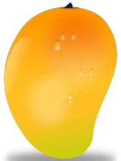 | 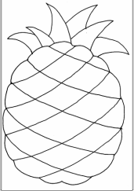 | 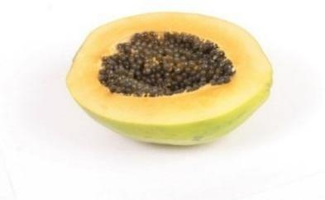
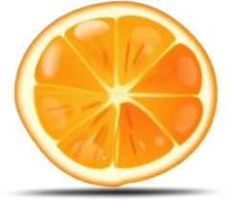 | 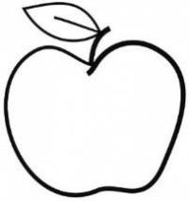 | 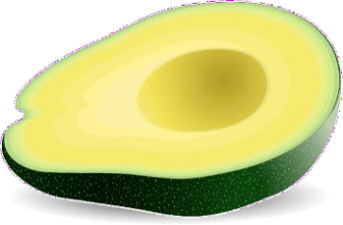

Name: Body Parts

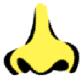 | 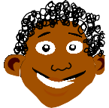
 | 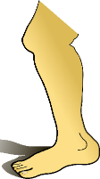
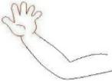 | 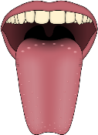
 | 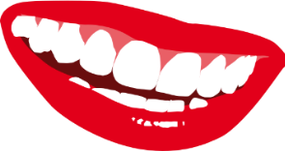
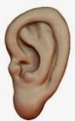 | 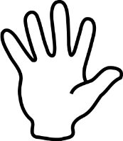

 |  | Food we eat
 |  |  | 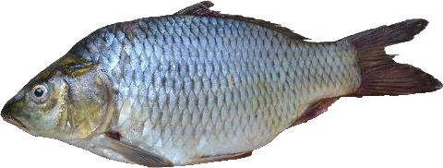 | 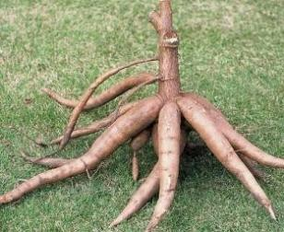 | 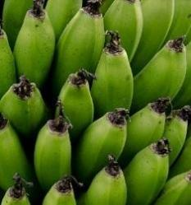
 |  |  | 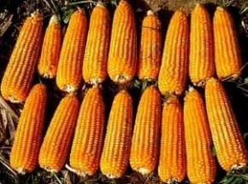 | 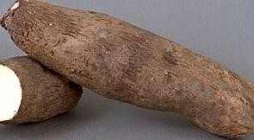 | 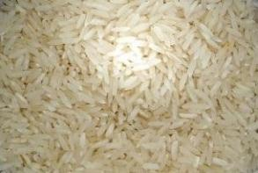
 |  |  | 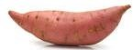 | 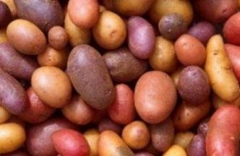 | 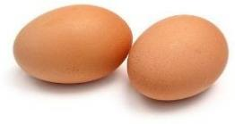

LEARNING AREA 3 (HEALTH HABITS)
TAKING CARE OF MYSELF FOR PROPER GROWTH AND DEVELOPMENT.
TERM II.
Week 2
My body parts
Naming different parts of the body
WEEK 2-5
- Using the sense of touching and feeling to describe things and situations.
- I can tell textures, temperatures and forms of objects
Suggested developmental activities.
- Feeling and talking about forms of objects e.g. cycle, star.
- Feeling and talking about different textures of objects and things e.g. stones, cones, sticks, cloth.
- Classifying and naming objects according to texture.
- Playing guessing games.
- Modeling to represent textures.
- Matching objects according to textures.
- Thanking God for the gift of hands e.g. through songs, prayers and rhymes.
WEEK 6-10
- Caring for the body
- I can protect and care for my body.
Suggested developmental activities.
- Practicing feeling different things using different parts of the body.
- Talking about how to clean my body.
  - Thinking God for having made me e.g. through prayers, songs and
rhymes. “who made you and me,
Who made mammy and daddy?
Our father God
- Practicing keeping the body clean

Things we use to clean our body

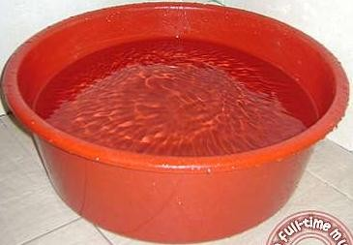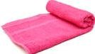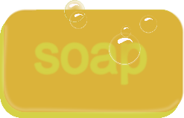

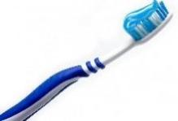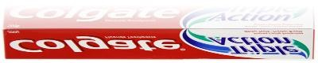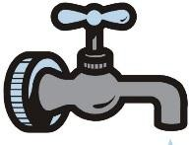

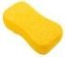
Activity Name the things used to clean our bodies

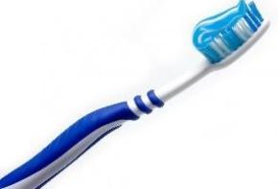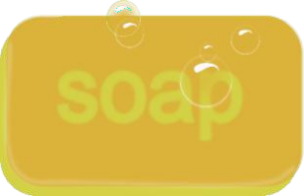

Uses of body parts
Eyes for seeing
Hands for touching
Tongue for testing
Legs for walking.
Ears for hearing.
Nose for smelling.

Toothbrush | soap | Basin

